Contact information :
Hailey.larson@psd201.org
Math 6 Online Letter to Parents
Dear Parents:
With the uncertainty of COVID-19 we have been instructed by the Preston School District to provide our students with mandatory online learning. This letter will address how this online learning will be delivered and accessed. Please read carefully the following headings.
- Online Learning Behavior Expectations:
  - Teams is a collaborative Microsoft app that your student has access to through Office 365. Students can chat with their teachers through their selected classroom. If your student has specific questions or needs help from their math teacher, please have them use Teams for any communications. They can open the Teams app using Office 365 and selecting Teams. Once Teams is open they can select the course they need to communicate in.
  - Students are expected to not use the chat format in Teams to chat with other classmates that are not relevant to the lesson being learned for the day or week. Students may chat with other class member to get help on assignments and ask questions about what they are learning.
  - Time spent learning in Online Math Classroom: Students will have a lesson to learn every school day. For each school day, they will need to watch any assigned videos, complete assignments and take quizzes and/or tests in Canvas. I will be posting grades at the end of each week. I encourage students to take notes from the videos they watch so they can complete assignments easier by referencing their notes. I will not collect the notes for points, but I recommend taking notes to help with their learning experience.
  - Late work will be accepted but is not recommended since we will have lessons daily. It is to your student’s best interest to stay caught up with their online learning for each school day. I will be reaching out to students who are falling behind their schedule of learning. Parents will be contacted with concerns about your student falling behind in their course work.

- How will my student access online learning?
  - Students will be expected to use a computer or device to access Canvas. Canvas is an online learning platform for students to access assignments, quizzes and tests. Students can also access videos of lessons they need to learn.
  - Your student should know how to access Canvas. We have included instructions how to access Canvas at the end of this letter.
  - My plan is to communicate twice a week (Monday and Wednesday mornings after 10 am) with students via Canvas Announcements. Please have your student check Canvas regularly for announcements from their teacher.
- Deadlines for Assignments:
  - Canvas assignments will have deadlines. I will be flexible with accepting work within a given week. However, when assignments are over a week late, I will be contacting students and asking them to turn in their late work.
  - Beware of Late work: spending regular time each day on assignments will help students stay caught up.
  - Please note the deadlines for assignments. We suggest students look at the calendar in Canvas for their Math Course to stay on top of the deadlines.

- Contacting Mrs. Larson during school hours:
  - School hours: Monday through Thursday 8:00 am to 3:45 pm
  - Parents can email me with questions or concerns any time, but can expect an answer during school hours.
  - Students may communicate with me using Teams or emailing during the listed school hours.
  - I will be available for phone contact via appointments only. If you feel that your student would benefit with a conference call with me, please contact me via email and I can set up an appointment during school hours.
Thanks for being understanding during these circumstances. Don’t hesitate to reach out with questions or concerns!
Mrs. Larson
Math Teacher
Preston Junior High School

Accessing Canvas
1. Access your Outlook/Office 365 account. Click on the nine dots in the top left corner:
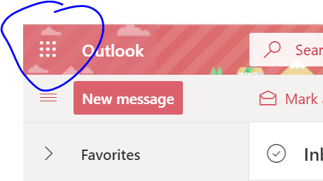

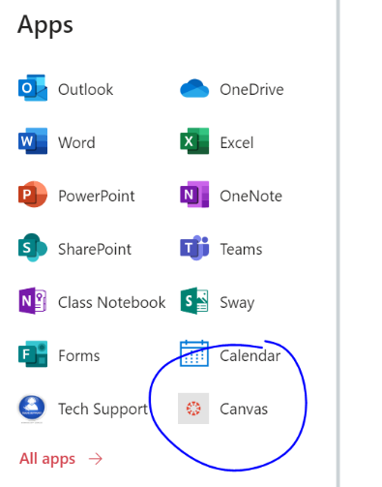
2. Then select Canvas: 3. Login with school account information if needed.
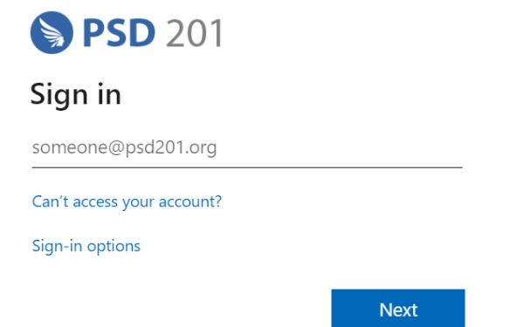
(Note: Teams can also
Be accessed this way)

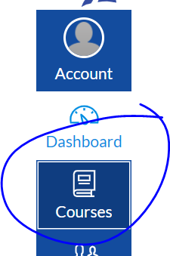
4. Access the desired course on the selection bar on the left hand side of the page:

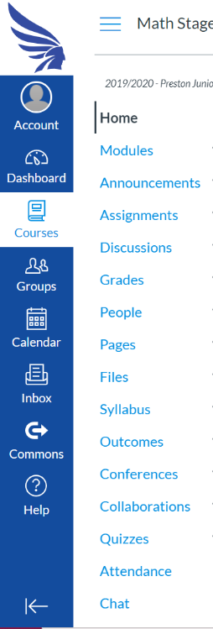

5. Follow course instructions from here! You can access modules, assignments, quizzes, embedded videos, and the calendar within the course.

